**Finite Element Analysis Report**

Project: 28-14428-04/73-19882-04

Work order: 2072AF015C

Reporter: SIFO

Date: 2020.07.15

**Summary**

* A linear static finite element analysis (FEA) was performed for a printed

circuit board tested on an in-circuit test fixture. The analysis was

performed for the fixture on the actuated position. In this position, all probes and board supports contact the board under test.

* The FEA calculates the following peak stress. strain and displacement:

|  |  |  |  |
| --- | --- | --- | --- |
| **FEA Result** | **stress** | **strain** | **displacement** |
| Peak Values | 9.87Mpa | 280μm/m | 0.0062mm |

* Stress can estimate whether the strength of PCB fills the bill or not. stress (vertical direction) is demanded less than 340 N/mm2(Mpa) ,and the calculated result was 9.87 N/mm2（MPa）. So the strength met the demand in a large extent, in other words , the probes and supports can’t penetrate PCBA.
* Board-level strain was examined to assess the potential effect on components mounted on the board. Board-level strains result from bending that is induced by the probe forces acting on the board. In general, strains greater than 500 μm/m can cause failure in some surface mounted components. and the calculated result was 280 μm/m. So the strain can met the demand .

**FEA Results**

**Stress**

* The peak board-level stress was calculated to be 9.87N/mm2(Mpa), which is below the elastic limit of FR4/G10 base material.

Screenshot for stress

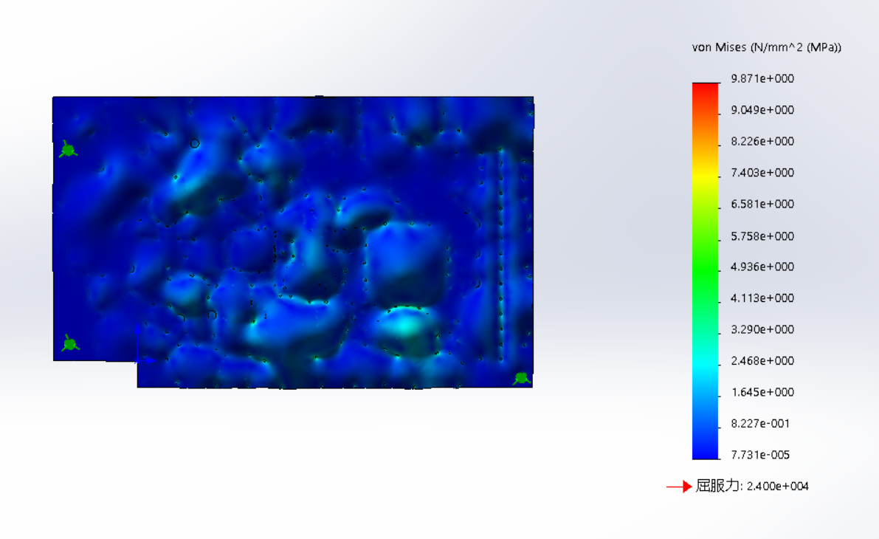

**FEA Results**

**Strain**

* The following plot shows strain distribution on the top of the board. The strains on the bottom of the board are equal magnitude but opposite sign (compressive strains on the top are tensile on the bottom).
* The peak strain was calculated to be 280 μm/m and is represented by the magenta-shaded regions. The peak strain is below the desired limit of 500 μm/m.

Screenshot for Strain

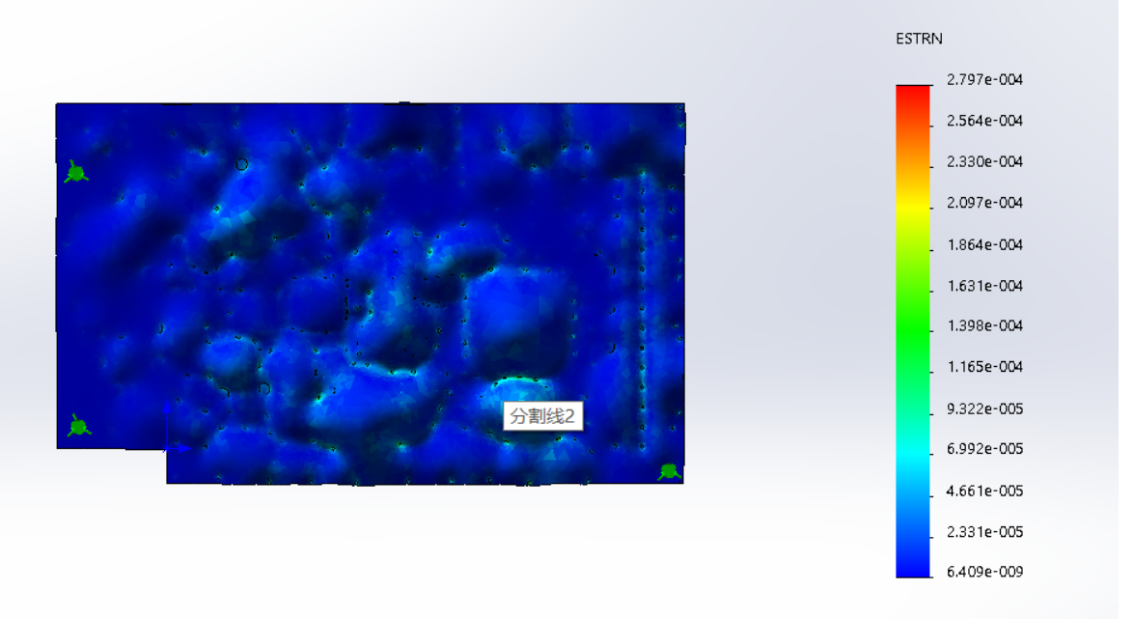

**FEA Results**

**Displacements**

* The following plot shows the displacement distribution across the board. The peak upward displacement was calculated to be 0.0062 mm



Screenshot for displacements

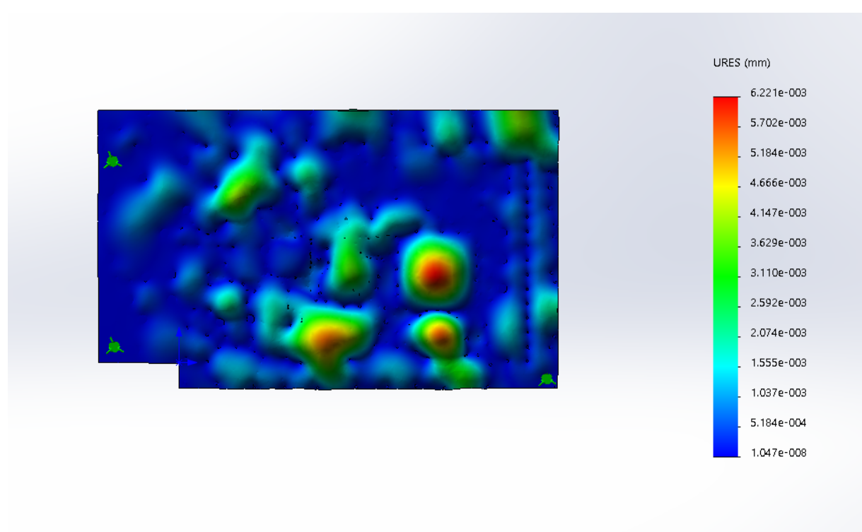

**Conclusions**

* For this board, FR4’s strength can meet the demand that is below the desired limit of 340Mpa. And the peak calculated strains are below the desired limit of 500 μm/m. Therefore, the fixture provides adequate support to the board